EXPERIMENT 5 – DATA VISUALIZATION USING MATPLOTLIB

Aim
To visualize and analyze the credit card fraud dataset using Python and Matplotlib by creating bar charts, pie charts, box plots, and line plots to understand fraud distribution, transaction amounts, and fraud transactions across different hours.

Algorithm
Step 1: Import the required libraries such as Pandas, Matplotlib, and OS.
Step 2: Display the contents of the user's directory using os.listdir() to verify the available files.
Step 3: Load the credit card fraud dataset from the Excel file using pd.read_excel().
Step 4: Display the first five records and column names using df.head() and df.columns.
Step 5: Count the number of fraud and non-fraud transactions using value_counts().
Step 6: Create a bar chart to compare the number of fraud and non-fraud transactions.
Step 7: Calculate the distribution of fraud and non-fraud transactions using value_counts().
Step 8: Create a pie chart to show the percentage distribution of fraud and non-fraud transactions.
Step 9: Create a box plot for the amount column to visualize the distribution and identify possible outliers in transaction amounts.
Step 10: Group the dataset by transaction_hour and calculate the total number of fraud transactions for each hour.
Step 11: Create a line plot to visualize the number of fraud transactions occurring at different hours.
Step 12: Display all the generated visualizations.

Program:

import pandas as pd
import matplotlib.pyplot as plt
# Load the Excel dataset
df = pd.read_excel(
r"C:\Users\palan\Downloads\credit_card_fraud.xlsx"
)

# Display first five records
print(df.head())

# Display column names
print(df.columns)

# Bar chart: Fraud vs Non-Fraud Transactions
data = df["is_fraud"].value_counts()

plt.bar(data.index, data.values)

plt.title("Fraud vs Non-Fraud Transactions")
plt.xlabel("Fraud Status")
plt.ylabel("Number of Transactions")

plt.show()

# Pie chart: Fraud Transaction Distribution
fraud_count = df["is_fraud"].value_counts()

plt.pie(
fraud_count,
labels=["Not Fraud", "Fraud"],
autopct='%1.1f%%'
)

plt.title("Fraud Transaction Distribution")

plt.show()

# Box plot: Transaction Amount
plt.boxplot(df["amount"])

plt.title("Transaction Amount")
plt.ylabel("Amount")

plt.show()

# Line plot: Fraud Transactions by Hour
data = df.groupby("transaction_hour")["is_fraud"].sum()

plt.plot(data.index, data.values)

plt.title("Fraud Transactions by Hour")
plt.xlabel("Transaction Hour")
plt.ylabel("Number of Fraud Transactions")

plt.show()
Output:
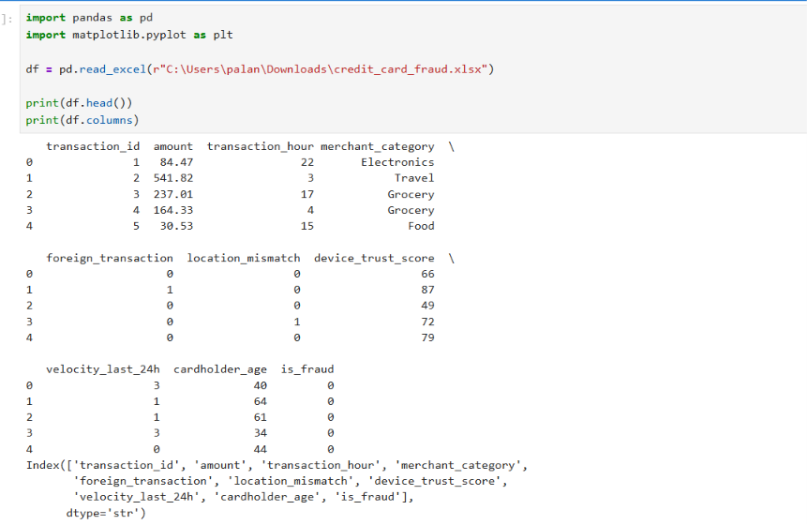
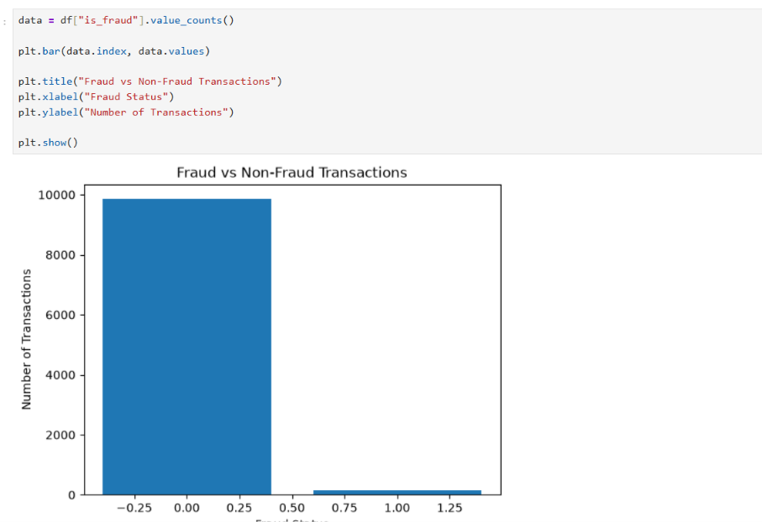

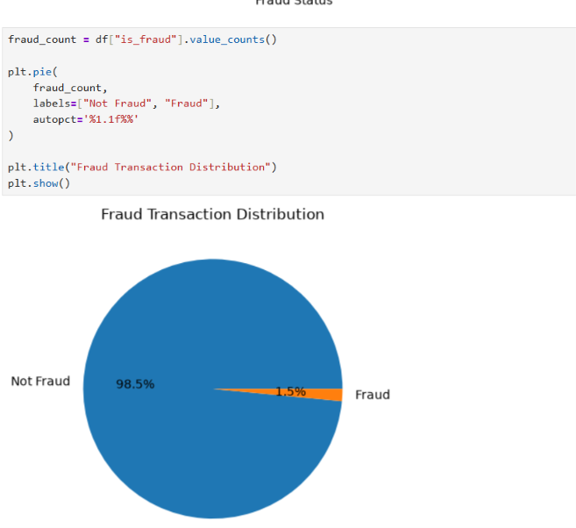

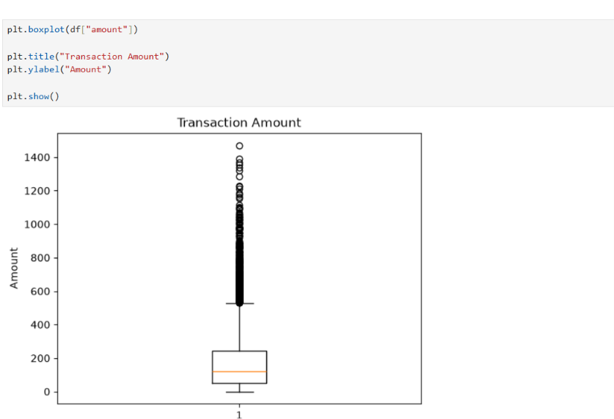
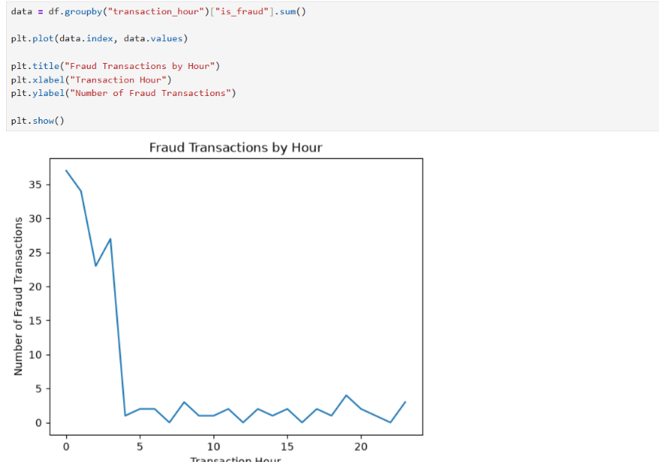

Conclusion
Thus, the credit card fraud dataset was successfully visualized using Matplotlib. Bar charts, pie charts, box plots, and line plots were used to understand the fraud distribution, transaction amount distribution, and hourly fraud patterns in the dataset.

